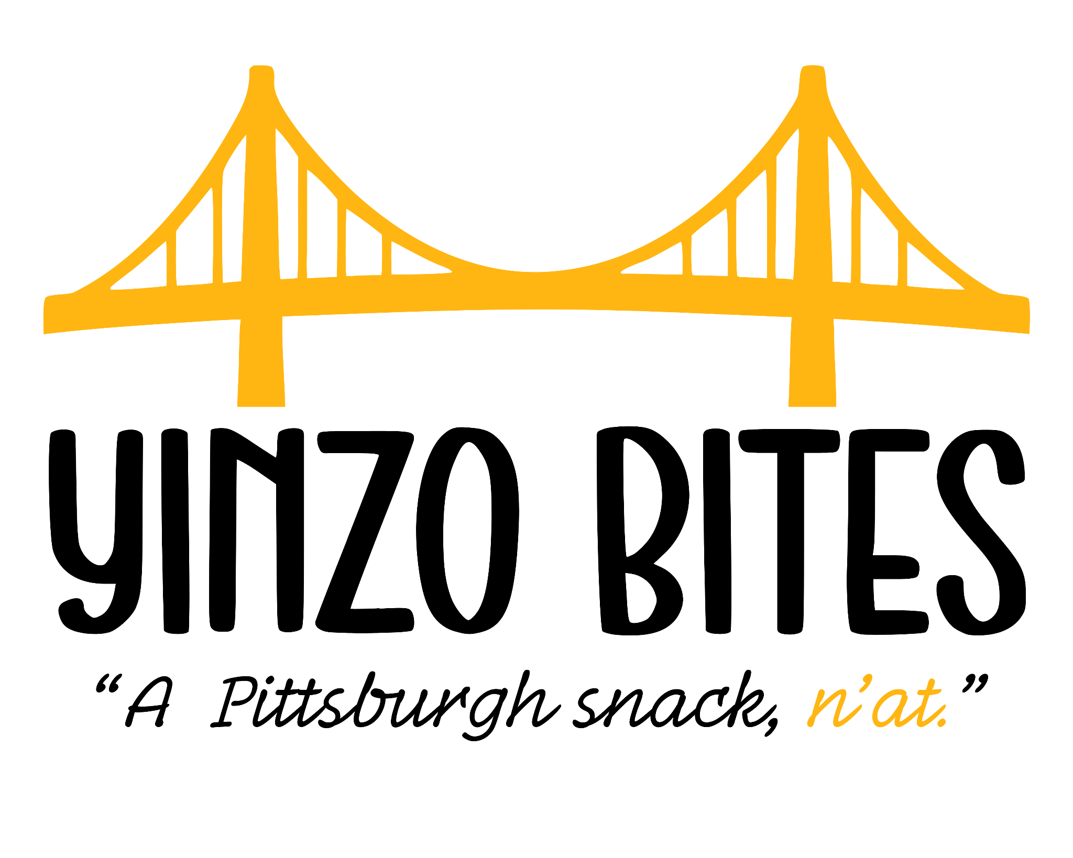
Contact Information

Christan McDowell, Product Marketing

Yinzo Bites Co.

412-867-0955

Pittsburgh, PA 15222

hello@yinzobites.com

Hershey HQ- 1-800-468-1714

Business Description

Yinzo Bites is a Pittsburgh-themed candy company that is focused on milk chocolate bites loaded with crunchy pretzel bits. The name is a tribute to the word “yinz” and the saying n’at which are so Pittsburgh! Every candy box includes images that are familiar to Pittsburgh - it’s yellow bridges. The candy is meant to remind people of the city’s personality made up of steel-town toughness, black and gold pride, and sweet-salty deliciousness.

Yinzo Bites was created for people who want a snack connected with the town they love. Each bite-sized piece has been created to be shared at school, tailgate parties, road trips, and game-day snacking. Yinzo Bites gives customers a hometown-proud treat that tastes as good as it represents Pittsburgh!

Target Customers

The primary customers are people from 18 - 35 who enjoy easy-to-eat, low-cost treats and have a connection to the Steel City. They are students at places like Pitt, CMU, Duquesne, and Point Park. They are sports fans, love the black and gold and love a connection to Pittsburgh. Secondary customers are visitors to Pittsburgh who are looking for a Pittsburgh treat as a Pittsburgh gift to enjoy while in town and to take home.
Competition

Competitors for Yinzo Bites are national brands that make the same “movie boxed candy” like The Hershey Company (Reese’s Pieces, Hershey’s) and Nestlé (SweeTarts, Nerds, SnowCaps, Raisinets). Competitors also include Pittsburgh’s own Sarris Candies company and Boyer Candy Company that makes Clark Bars and Mallo Cups.

Branding Elements
Candy logo, packaging for big at home bags and boxed Yinzo Bites, website, rack cards, flyers, social media templates, Pittsburgh merchandise like t-shirts, hats, tote bags, and stickers
Brand Guidelines
The brand uses yellow as its main accent but can use all Steelers colors black and gold with white, red, and blue. The tone is friendly and bold with hometown pride. Colors should be used in a classy way. Pittsburgh details like the skyline, bridges and Pittsburghese words like Yinz and n’at are used to support the hometown theme.

